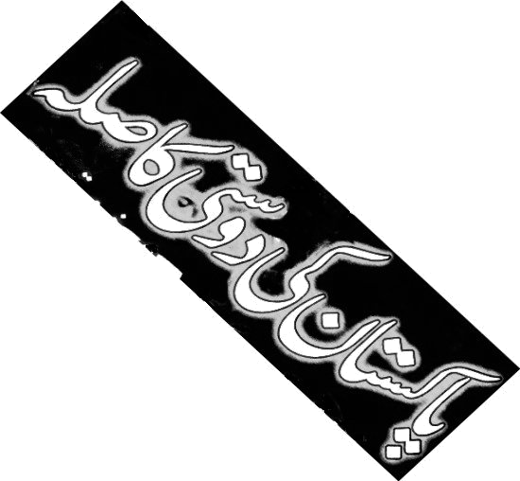
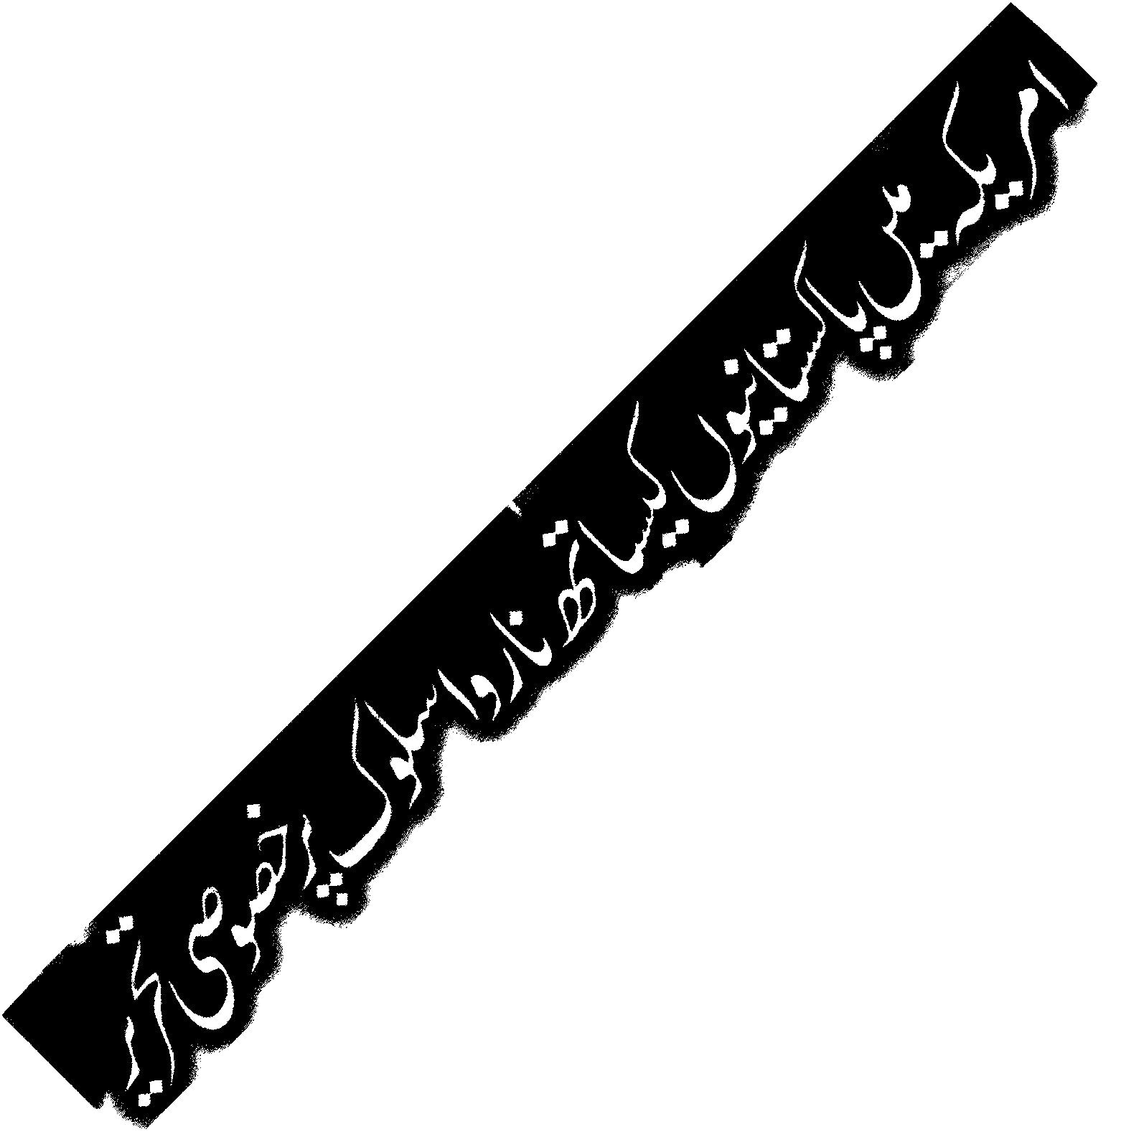
STOP Attacking

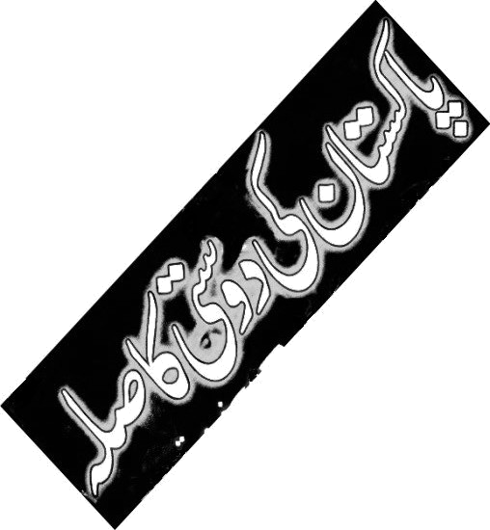
Immigrants!

The drive to
war is being
fueled by the
scapegoating of
innocent Muslims,
South Asians, Arabs
and immigrants, fanning
fears so that citizens feel it is
“necessary” for the United States to launch a new war on Iraq.
Please join a community march to
say stop the attacks on
immigrants, repeal the
registration act, and
NO to war on Iraq!
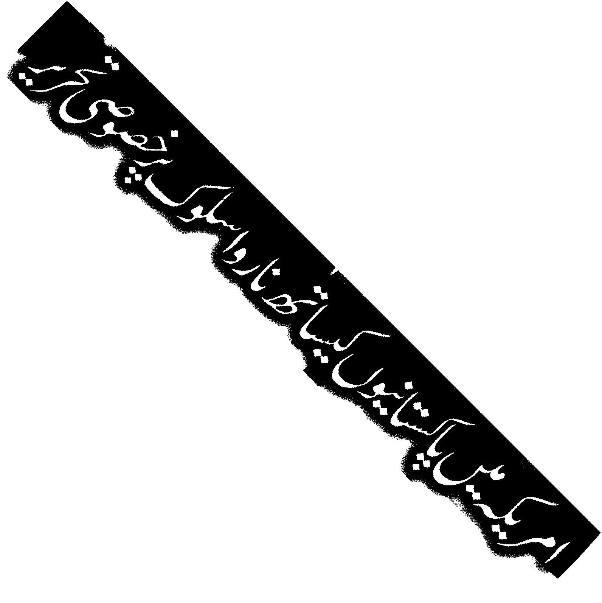
February 15th is an international day of protest against war on Iraq,
with protests planned in New York and all the major capitals of Europe. It is also just 6 days before the “registration” deadline for many Pakistanis in the United States, the same “registrations” which led to the arrests of more than 1000 Iranians in Los Angeles a few weeks ago.
No more

war abroad!

* Pakistanis and Muslims: Stand up for your rights!
* All others: Stand in solidarity with your brothers and sisters – your rights could be next!

.
12 noon - Saturday, Feb. 15, 2003

2200 W. Devon, Chicago
(Devon & Leavitt in the heart of the Pakistani community)
Co-sponsored by (list in formation): American Muslim Alliance-Midwest, Andersonville Neighbors for Peace, Arab American Action Network, Arab-American Community Center, Blue Triangle Network, Campaign For Collateral Compassion, Chicago Anti-Bashing Network, Chicago Coalition Against War & Racism, Chicago Labor Against the War, Chicago Peace Response, Chicago Professional Taxi Cab Drivers Association, Church & World Concerns Committee-Broadway United Methodist Church, Coalition of Pakistani Organizations, Committee For a Democratic Palestine, The Council of American Islamic Relations, DePaul Students Against the War, Eighth Day Center for Justice, Free Palestine Alliance, Generation Y, Granada Muslims and Jews for Human Rights, International A.N.S.W.E.R. Coalition-Chicago Chapter, International Action Center-Chicago Chapter, International Socialist Organization, Iraq Peace Pledge, La Voz de los de Abajo, MARC, Mohammadan Muthida Minority Movement, Muslim Civil Rights Center, The Muslim League USA, National Lawyers Guild-Chicago Chapter, Neighbors For Peace, Not In Our Name, Pakistan American Democratic Forum, Pakistan Memon Association, Pakistani American Association of North America, Pakistani American Congress, Pakistani American Democratic Forum, Pakistani Business Association, Palestine Solidarity Group, Real Conditions Writers' Collective, Refuse & Resist, Revolutionary Communist Youth Brigade, Sangat-Chicago, Sargam Radio Channel 1240 AM, Socialist Action, Socialist Party USA, Southwest Youth Collaborative, Students For Social Justice, Weekly News Pakistan
For information or to co-sponsor, e-mail CCAWR@aol.com or call 888.471.0874
¡Alto a los ataques

contra
El impulso
a la guerra
es abastecida
por la demoniza-
zación de ino-
centes–musulmanes,
surasiáticos, árabes e
inmigrantes–intensificando
el temor para que los ciudadanos crean que una Guerra nueva contra Irak es necessaria. Por favor únase con nosotros en
una manifestación de la
comunidad al decir: ¡Alto a
los ataques contra
inmigrantes!
¡Revoque del Acto
de Registro!
¡NO a la
guerra
contra
Irak!
inmigrantes!

El 15 de febrero es un día de protesta internacional contra la guerra en Irak. Se planean protestas en Nueva York y todas las cuidades principales de Europa.
Además, el 15 de febrero es seis días antes del plazo de registración de muchos pakistaníes en los Estados Unidos—la misma registración, que hace pocas semanas resultó en las detenciones de más de 1,000 iraníes en Los Angeles.
más
¡No
guerra

contra el mundo!
* Paquistanies y musulmanes: ¡Defendan sus derechos!!
* Todo el mundo: Muestre solidarícense con sus hermanos y hermanas.
¡Sus derechos pueden ser los próximos afectados!!

.
Mediodía - Sabado, 15 de febrero, 2003

2200 W. Devon, Chicago
Esquina de Devon y Leavitt, el corazón de la comunidad paquistaní Chicago. Para información sobre transportación llamar al:
Co-patrocinado por (lista en formación): American Muslim Alliance-Midwest, Andersonville Neighbors for Peace, Arab American Action Network, Arab-American Community Center, Blue Triangle Network, Campaign For Collateral Compassion, Chicago Anti-Bashing Network, Chicago Coalition Against War & Racism, Chicago Labor Against the War, Chicago Peace Response, Chicago Professional Taxi Cab Drivers Association, Church & World Concerns Committee-Broadway United Methodist Church, Coalition of Pakistani Organizations, Committee For a Democratic Palestine, The Council of American Islamic Relations, DePaul Students Against the War, Eighth Day Center for Justice, Free Palestine Alliance, Generation Y, Granada Muslims and Jews for Human Rights, International A.N.S.W.E.R. Coalition-Chicago Chapter, International Action Center-Chicago Chapter, International Socialist Organization, Iraq Peace Pledge, La Voz de los de Abajo, MARC, Mohammadan Muthida Minority Movement, Muslim Civil Rights Center, The Muslim League USA, National Lawyers Guild-Chicago Chapter, Neighbors For Peace, Not In Our Name, Pakistan American Democratic Forum, Pakistan Memon Association, Pakistani American Association of North America, Pakistani American Congress, Pakistani American Democratic Forum, Pakistani Business Association, Palestine Solidarity Group, Real Conditions Writers' Collective, Refuse & Resist, Revolutionary Communist Youth Brigade, Sangat-Chicago, Sargam Radio Channel 1240 AM, Socialist Action, Socialist Party USA, Southwest Youth Collaborative, Students For Social Justice, Weekly News Pakistan
Para más información o para co-patrocinar, e-mail CCAWR@aol.com o llama a 888.471.0874

